Week 2 Reading
Strategy and the process of strategic management pg39-62

Strategic problems and the strategies of firms
- Notion of strategy is subject to a confusing variety of interpretations.
Defining strategy: misunderstandings
- Mintzberg argued, unhelpful to equate strategy with strategic plan, a strategic plan is a formal document setting out an orgs goals and initiatives over a defined time period. Strategic plans more likely to be found in large complex companies which have major problems with coordinating efforts towards common goals.
- Formality of strategic planning is unusual in small businesses, but firm still has strategy just not written down, obvious by choice of managers.
- A firms strategy is the set of strategic choices that is revealed in the characteristic ways it behaves.
- Strategy is best discerned in behaviour, not in formal planning documents.
- Strategy is not tactics, tactics help us achieve our strategy, and they are a means to reach them.
- Both our goals and our means are critical to our success.
- In business astute leaders realise the importance of taking care with both ends and means. That’s why many mangers start at the bottom and work their way up for experience in these matters.

The problem of viability
- Strategy is best defined by making a distinction between the strategic problems firms face in their environment and the strategies they adopt to address them.
- Most critical challenge that firm faces is that of survival, problem of becoming and remaining viable in its chosen market.
- In Order to be viable firms require a set of goals, resources and capable people that are appropriate to the industry concerned.
- Decisions are strategic; they are making or break factors. Get the system right and the firm will be viable.
- Four critical elements in a viable business model: marketing, funding, production system and hr
- Marketing- firm needs to develop product service that can meet a profitable set of customer needs.
- Stable production system, a credible way of making the product, suitable production tech or know how and reliable operational processes are critical to survival.
- Needs financial backing to pursue its goals.
- There is no solution to the problem of viability without capable people. A suitable way of managing work and people is necessary.
- The four elements of marketing, production. People and funding interact with each other over time. All affect each other.
- A viable business model is one which puts these pieces together in a profitable and sustainable way.
The problem of sustained advantage
- Firms that survive are engaged in a struggle to build and defend competitive advantages.
- A firm which builds a relatively consistent pattern of superior returns for its shareholders has developed some form of sustained compet advantage, or achieved what the economic theory of the firm has called rents; profits above those that can normally be earned in conditions of perfect competition.
- Goal is to engineer imperfect competition favouring their firm
- Many advantages are temporary. Hard to defend your position.
- Firms must meet certain base line conditions that make them similar to other firms while also having the opportunity to make gains from being positively different.
The strategies of firms
- The strategies of firms are their particular attempts to deal with the strategic problems they face.
- Best strategies reach beyond viability to master problem of sustained advantage.
- Emergent strategy – Mintzberg – a sets of strategic choices, some of which might stem from planning exercises and set pience debates in senior mang and ome of which stream from action. Learning shapes strategy over time
- Strategy contains choices about inward and outward elements, problem of choosing suitable goals and problem of choosing and organising resources to meet them.
- To be successful firms need an effective system of choices involving all the key dimension of the business, marketing ,production, hrm and finance.
- Extent of choice, some firms have more degrees of freedom.

The process of Strategic Management
- Process of forming and reforming.
Strategic management and human cognition
- Human cognition is a psychological term for thinking processes, for our ability to process info and make decision.
- We can find goals or the element of intent is human action.
- Work of strategic man is finding a desirable path for the firm and managing its resources accordingly is complex work that takes place in an environment of risk and uncertainty.
- We have reasons or goals for our actions
- We often have to act without knowing everything we’d like to
- We often commit emotionally to a failing course of action
- We tend to search for confirming rather than disconfirming evidence to support our views.
- In problem solving we often leap to a favourite or preferred solution without disciplining ourselves to diagnose the problem more deeping.
- No single executive in a large firm is likely to have all the answers
- The mang process tends to repeat yesterday’s success formula

Strategic management and organisational politics
- Cognition – cleverness – counts for a lot in a company success.
- Any major initiative involves political management, particularly where investors must be persuaded to support, or where employee groups are being asked to makes changes that threaten their interests.
- Most of political difficulty of strategic mang occurs within the mang structure itself.
- Managers who head the historically strong departments often fight change even when the larger picture indicates that strategic change is needed
- Individual managers have personal reasons to advance their own interests irrespective of whether they are located in a powerful department.

The role of hrm in improving strategic management processes

The importance of executive recruitment and development]
- The greater the uncertainty and discretion involved in work ,the more important it is to hire or develop people of high ability with a well-rounded intellectual and emotional profile.
- Failure to recruit and retain suitable managers will hamstring company performance.
- A lot of money spent recruiting best managers
- Evidence that senior hr specialist orient their jobs to focus on critical activities associated with managing managers
- Strong emphasis in their work priorities on developing exe capability and performance.
The role of team building
- We should not think that strategic mang process will improve solely as a result of selecting or developing higher performing individuals.
- Team processes vital to performance. Need person job fit AND person team fit.
- According to belbins, it is a mistake to construct mang teams simply based on the functional expertise of individuals. Most effective mang teams enjoy a healthy mix of complementary teamwork styles. Seen in below table
- 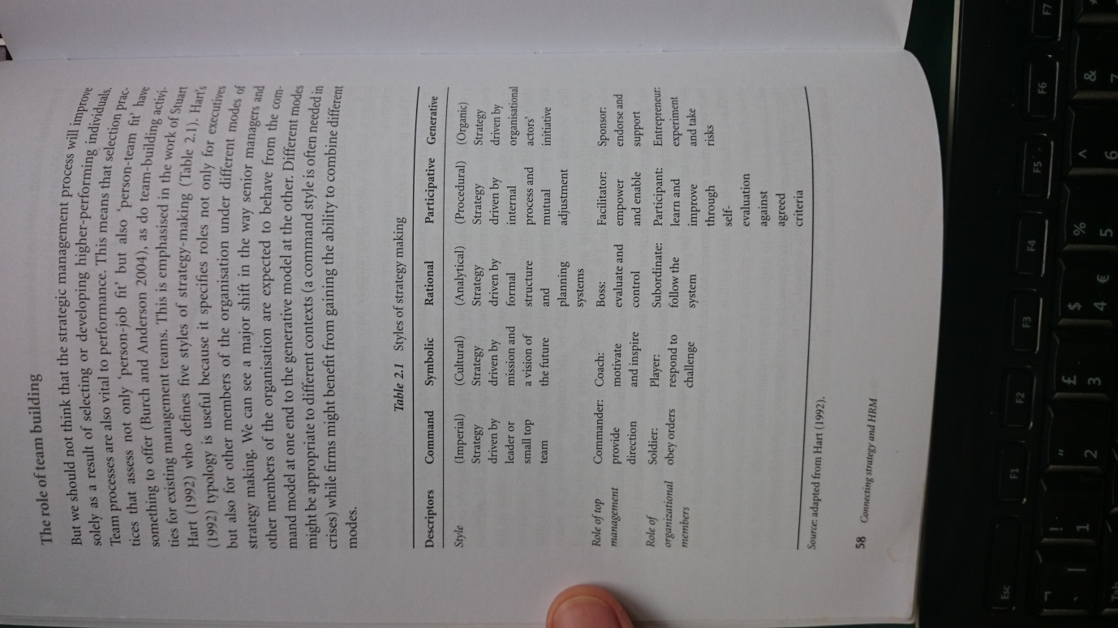
- 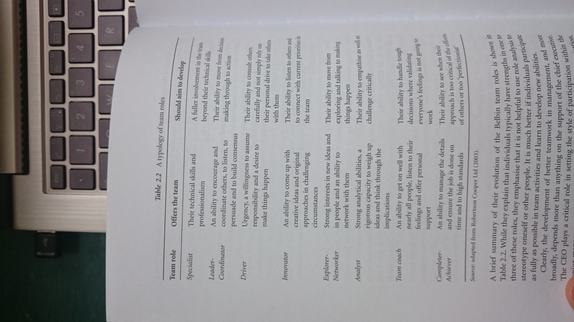

Summary
We have defined strategy by distinguishing between strategic problems the firm faces in its environment and the characteristic ways it ties to cope with them , its strategy.
The fundamental strategic problem is viability or survival.
To be vialbe firm needs set of goals and relevant set of human and non human resources, a configuration or system of ends and means consistent with its survival in the context in which it operates.
Long with an appropriate approach to marketing, operations management and finance, this means that firms need a cost effective approach to hrm.
Without certain kinds of capable and motivated people, firms are simply not vialbe.
Firms that achieve some form of competitive advantage will not be completely different from those that do not, due to the need of all firms in the industry to have table stake,s features that make them similar to each other.
Strategy is a set of strategic choices, stream over time.
Strategic mang is the process used in firm to develop critical goals and resources.

